EASTERN INTERNATIONAL UNIVERSITY  SCHOOL OF COMPUTING AND INFORMATION TECHNOLOGY | Practice Assignment – Quarter…, 20…-20…  Course Name: Backend Development  Course Code: CSW 306  Student’s Full Name:  Student ID:
Practice Assignment 1

I. Prepare
1.1 Install Visual Studio Community 2022 (Skip if you have already installed it)
- Go to https://visualstudio.microsoft.com/downloads/
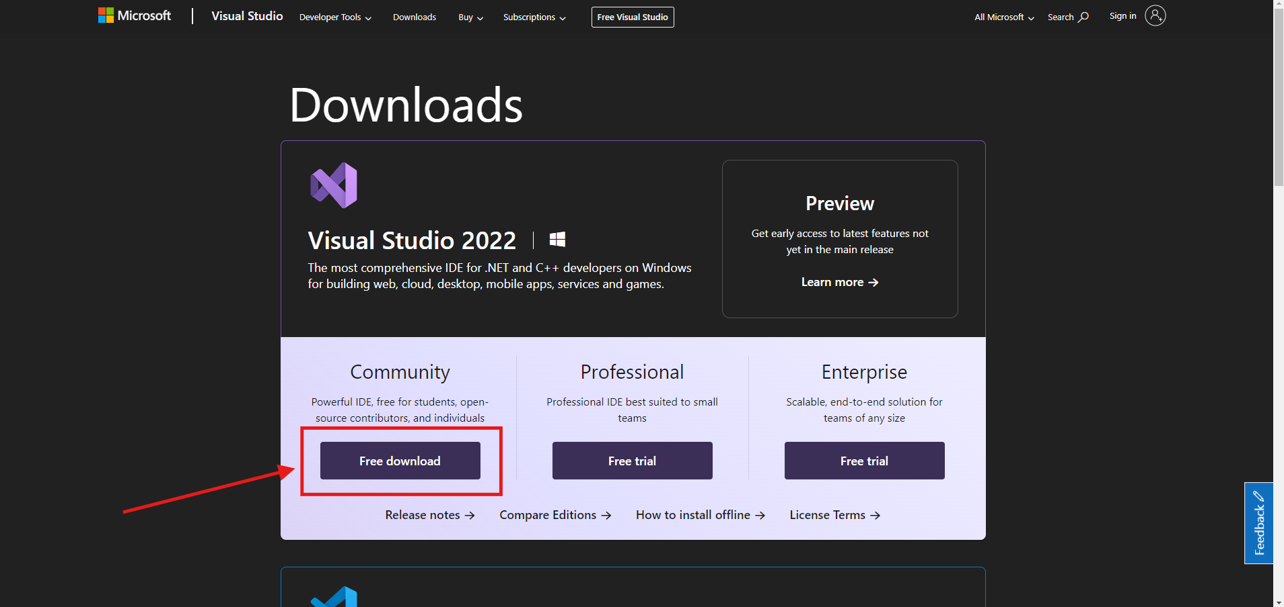
- After downloaded, open the file “VisualStudioSetup.exe”  for install. 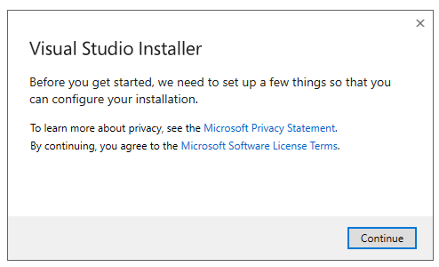
- Click continue and wait for download the package for install.
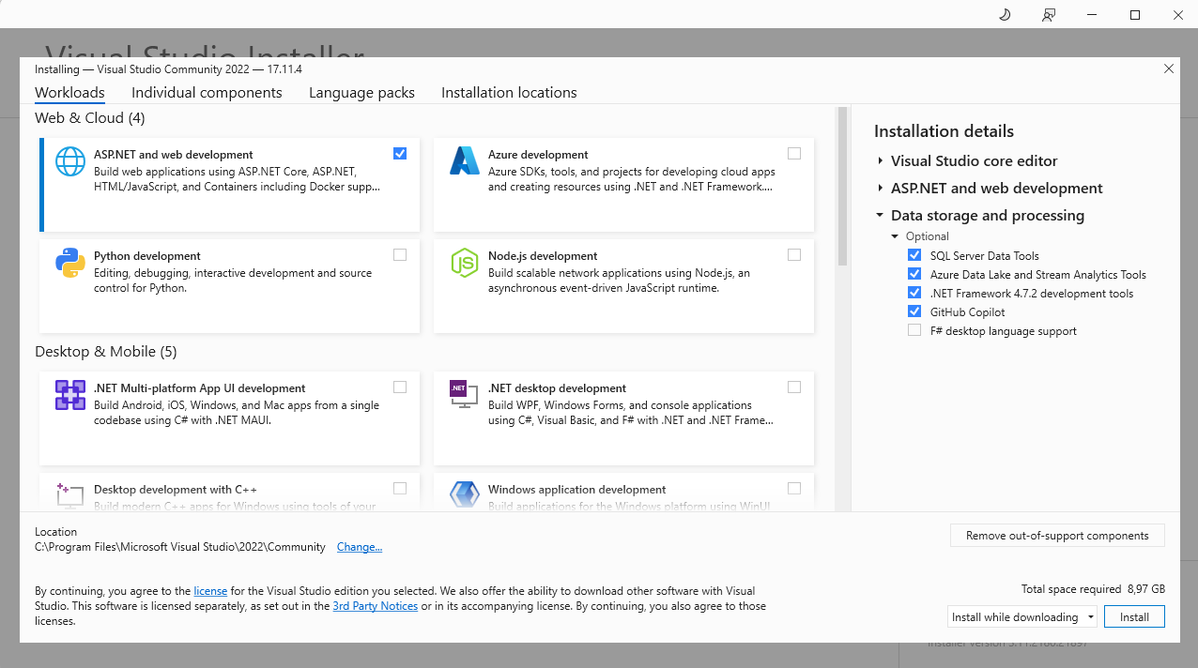
- Tick at “ASP.NET and web development”
- Tick at “Data storage and processing”
After that click install button and wait until that finish.
1.2 Install the Microsoft SQL Server developer 2022 (Skip if you have already installed it)
- Download the installion file here: https://drive.google.com/file/d/106Rkzny9Ur5RVCSC0ET-_eY4PFjXsVTW/view?usp=drive_link
- After download the file, click to 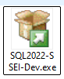 to install
- The next window will be like this:

Choose the “Basic” version and then install.
- When the installation is complete, click 'Install SSMS' to install the management interface and access the DB engine. Alternatively, you can click the link to download it: Download SSMS: https://learn.microsoft.com/en-us/sql/ssms/download-sql-server-management-studio-ssms?view=sql-server-ver16
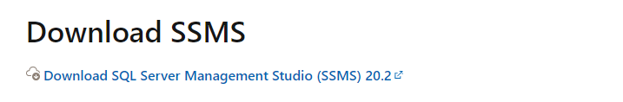
Okay! After you finish the preparation, let’s do the exercise below.

II. Exercise
Q1: Using the Visual Studio create a simple console project following the naming convention YourName_StudentID_Lab1.
Requirement:
- Namespace is “YourName”
- Class with Access Modifiers is public and name is “Program”
- Have a main function inside class
Q2: Print text 'Hello World' to the console in the main function of the project.
Q3: Create a function to add two numbers with two input parameters called number A and number B of type int, then return the sum of A and B. And call the function your write inside the main function.

Q4: Create a function to swap two numbers with input parameters called number A and number B. The function will print the result to the console after the swap. And call the function your write inside the main function.
Q5: Write a function to input a student's average score and determine the classification as follows:
- 90-100: Excellent
- 80-89: Good
- 70-79: Fair
- Below 70: Average
And call the function your write inside the main function.
Requirement:
- Using IF statement, Else IF statement.
Q6: Write a function to input the number and print the corresponding month name. Use if to check the validity of the number is the valid month (1-12 month) and switch to determine the month.
Example:
When you type “5” the output of function is “May - Have 31 days.”
When you type “9” the output of function is “September - Have 30 days.”
When you type “19” the output of function is “The month input is invalid”
Requirement:
- Use an IF statement to check the condition and a SWITCH statement to determine the month.
Q7: Write a function that takes a positive integer as a parameter, calculates the sum of all numbers from 1 to the entered number, and outputs the result. It is required to check that the entered number is valid. And call the function your write inside the main function.
Requirement:
- Use an IF statement to check the condition and a LOOP statement to solve the problem.

